Restaurant business plan
BY
john ajokaiye
15496
international relation gns 311
dept. of elect/elect engineering
niger state polytechnic, zungeru.

Restaurant Business Plan in Nigeria
Abstract
The restaurant will be an eating establishment focusing on healthy, nutritious and fast food to the local downtown area. It will be a moderately priced of 56 seat restaurant that is decorated with feature word accented chairs with blue and white checked table cloths.
Dinner style tables will be surrounded by wooden chairs with comfortable seating cushions offering family style food and service.
Based on this distinct menu, the restaurant will follow a differentiation strategy that will provide unique, or hard to find choices to the customers.

The operators must have about 12-15 years experience in the restaurant and catering industry. Entering into this market will not be easy, the industry is highly competitive with periodic overcapacity, low margins and low entry/exist barriers.

In addition, there are large numbers of substitutes and the suppliers to this market have a great deal of power.

In order to overcome these issues, the restaurant has acquired an excellent locality in the downtown area and intends to provide a suitably upscale environment to draw in the restaurant main target market segment and business professionals.
The company will seek to provide these customers with the maximum number of services to create the greatest sales volume during the restaurant peak hthes of operation. The restaurant will have a comprehensive marketing, advertising and promotion campaign that will maximize word of mouth marketing and will consist of radio, printed materials, bill boards and discounts.
The restaurant has planned to offer its products at a slightly higher price than its competitors. This is to provide credibility to its clients as an upscale establishment that provides a unique menu. This will also provide the funds to cover the higher than expected operating costs
due to the differentiated and expanded menu. The sales projections assume 1,800 customers per week.
This resulting to the weekly sales of just over N720,000:00 this if projected for three (3) years is calculated as N720,000 X 52 weeks = N37,440,000:00 for 3 years (N37,440,000x3) = N112,320,000:00 By this, the restaurant is maintaining a healthy cash flow.

INTRODUCTION
Company Description
The Restaurant will be located in the North central part of Nigeria, the capital city of Kogi State called Lokoja. The restaurant will serve a variety of classic home-style favorites majorly in African dish and other favorite fruits and juices.

The Restaurant will be Open 6 Days Per Week
Monday 8:00 am – 9:00 pm
Tuesday 8:00 am – 9:00 pm
Wednesday 8:00 am – 9:00 pm
Thursday 8:00 am – 9:00 pm
Friday 8:00 am – 10:00 pm
Saturday 11:00 am – 10:00 pm

Start-up Summary
The total estimate of opening the restaurant is N10, 000,000.00. The majority of the expenses are on furnitures, fixtures, and equipment which amounted to N3,500,000.00. The location requires some buildout and renovation totally N300,000 and will require approximately 30 days to complete. About N 6,000,000.00 of the start-up cost will be funded by the owners. The owner’s source of funds is a combination of liquid assets and marketable securities primarily from their existing catering business.

Location and Facilities
The 2,000 square foot restaurant will be located in the Abuja express highway called Lokoja the capital city of Kogi State. Lokoja has about 20,000,000 populations and a very busy area that lead to the federal capital territory of
Nigeria. The commonest language there is Yoruba, Ebira, Igala and Bassa Nge.

Weekly Inventory
Management will conduct a weekly inventory to determine valuation for use in the preparation of weekly profit and lost reports.

Daily Inventory Tracking
Daily inventory will be taken on specific items. Movement will be compared to sale data to ensure designated products have been properly accounted for.

Administrative Systems
It is crucial that the The Restaurant remain current with daily easy outlay. The purchase of a POS system will immensely help them with these daily administrative reports.

Daily Cash Control
Sales and receipts recorded by the POS system will be compared to actual cash and credit card deposits on a daily basis. Monthly totals will be compared to actual P & L statement for accuracy. Cash, debit Card and Credit card receipts will be deposited in a deposit.

Weekly Prime Cost Repost
The Restaurant will prepare a weekly report that shows the gross profit margin after cost of goods sold and labthe cost has been deducted from the sales revenue. The prime cost for this type of restaurant is expected to range form 60% to 65%. Proper control to the prime cost is the single most effect measure of management’s ability to operate the restaurant.

Purchasing Records/Payable
A part time bookkeeper will process and record invoices and credits daily. Reports
detailing cash expenditures, payments by check and accounts payable transactions will be readily available. Check disbursements will be prepared by the bookkeeper. Check signing authority for the general operating account will be given to the general manager.

Payroll Processing
Payroll checks will be issued bimonthly. The Restaurant will run reports from the time and attendance system, make necessary adjustments, and prepare for transfer to the payroll system. Payroll will be processed by a payroll processing system.

Future Services
The Restaurant Restaurant has a future plans to provide catering services for family reunions, weddings and other event desiring a “home-style” menu. This could potentially become a large portion of gross sales.

MARKET ANALYSIS
The restaurant industry is a large and diverse business. They industry increase in percentage against the first year of its sales and profit. The overall economic impact of the restaurant industry is expected to exceed the percentage profit increase from its previous years. The industry consists of full-service restaurant and limited service eating places which include quick service restaurant, cafeterias, buffets; snacks bars and non-alcoholic beverage bars.

Industry Analysis
Comprises carefully manage inventory of perishable food products, such as fresh seafood and dairy foods to reduce losses due to spoilage. Computerized information system can improve and link food preparation and serving operations. Timing system monitor meal progress and can alert staff if an order is running behind schedule. Inventory management systems tracks supply levels and can help reduce waste due to spoilage.
Cost accounting programmes help compares to determine the profitability of individual menu items. Point of Scale (POS) devices allow servers to place orders and print checks tableside, improving accuracy and
reducing ordering time.

Market Segments
The location was selected primarily because it is in a capital city of the state and also a major area leading to the capital city of Nigeria (Abuja) and also is located close to the Federal University, Lokoja. The residential population in the immediate area comprised of a mixture of students single family and multi-family housing.

Major Employers for the Restaurant Include:
1. Manager: Oversee the activities of the organization
2. Cashier: In-charge of finance
3. Calabar women :They will be in charge of the cooking in the Kitchen
4. Young men and Young ladies: They serve as the waiters
5. Cleaners: They are in-charge of cleaning tables/chairs and environment
6. Bar man: They are in-charge of drinks
7. Old women: They are washing plates
8. Security: They make sure that things are kept intact.

Market Tests
The operators of the restaurant have about 12-15 years experience in catering and hotel business in the state before. They have customers before and their business Name is well recognized in the state. Their customers will be the first set to be contacted when they announce the grand opening of the restaurant.

TARGET MARKET SEGMENT

STRATEGY:
The area was selected primarily because of its location that is very busy intersection with the connection of Okene high-way from the west, Ajaokuta high way from the East and Abuja highway from the North. The restaurant is located at the “going home” side of the Federal University, Lokoja. This will encouraage workers to easily locate the place and take launch during the break period from the office and also easily ease stress of workers or families tired from a day of work to stop in for a home cooked meal they can enjoy.

Market Trends
According to the National Restaurant Association of
Nigeria. The top 5 trends are as follow
• Locally grown produce
• Locally sourced meats and sea fish
• Nutritious kind’s dishes
• Hyper –local items (like the local noru, fresh
vegetables, fresh tomatoes etc).
• Hygienic Environments

M A R K E T S T R AT E G Y A N D IMPLEMENTATION

The restaurant will do this by providing quality home style meals, prepared with quality ingredients at reasonable prices. Customers will enjoy the quaint surroundings inside with the plastic and wood table and checkered table cloths. The restaurant will provide a relaxed atmosphere and when customers walk in; they will be greeted by warm smiles as if they were arriving home.

The customers will enjoy the standard menu fare, along with seasonal menus so that the restaurant can better take advantage of cost savings and stay current with some of the food industry trends.

The Restaurant plan to be the premier restaurant and work for as well. The restaurant management will pay employees a competitive salary and believe this can be done by meticulously keeping records, including daily review of the prime cost Report and utilize the cost Accounting systems to prevent inventory shortfalls. The restaurant will be proactive with the employees by scheduling regular performance reviews and provide bonuses and other incentives to motivate the staff. The restaurant will also provide its employees with the most current training programmes regarding safe food handling and worker protection.

The Restaurants will also remain current with current industry marketing trends. In addition to a website with the menu, map and driving directions. The restaurant will also have a Facebook page and utilize other social media such as Twitter pages for relevant advertisement.

Strengths
• Very good location with easy access from interstates.
• Employing exceptional staff with the “yes we can” attitude. Combined with the operators 12-15 years experience in hotel business. Due to the small size, the restaurant believe it can provide exceptional quality by hand selecting the market specials when compared to larger corporate competitors.
• The operator that will be employed, must have hotel experiences in the capital city of Kogi State, Lokoja, such that they have already established customer market.
• The employees will strive to offer unsurpassed service when compared to the larger competitors.

Weaknesses
• Recruiting and retaining quality employees
• Tight margins will allow little wiggle room for error.

Opportunities
• Little entry barriers allows for immediate business opportunities
• Offer additional catering services

Threats
• Government mandates Restaurant Operation, Food Safety of Nigeria, Sanitation, National Agency for Food, Drugs and Administrative Control (NAFDAC).
• Rising Operating Costs
• Building/maintaining sales volume
• Supermarkets and convenience stores (mama puts)
• Consumers that believe who believe the home meal is nutritious than those prepared in the restaurants

Strategy Pyrami
The Restaurant restaurant shall be seen as customer satisfaction base.

Tactics
Creation of awareness: The signage on the front of the restaurant will bring customers to restaurant and once inside; will immediately acknowledge the customer with warmest and most sincere greeting and begin the service process anticipating the repeat of customers.

Programs
Provide employees training on customer service and retention; offer ongoing training programs for employees keeping them current on industrial trends and food safety. They track of employee’s progress through performance reviews and offer employees incentives attracting and retailing customers.

Sales Strategy
Customer services are of the utmost importance. A customer survey estimate that only 1 in 20 customers that have a problem in a restaurant will tell management about it. It will be of the goal to provide a wonderful home-style meal combined with superior customer service. Training programms will include teaching materials to train the employees about service attitudes, customer perception and how to handle guest complaints. Ikemefuna and Enoch will conduct periodic staff meeting intended to review policy, increase guest satisfaction and complaints will be acknowledge by the staff and referred to management. Programme will be put in place for all types of guest complaints. More serious complaints will be documented and kept on file.

Sales forecast
The restaurant will conserve 5% increase in sales revenues annually over the next 3 years. The growth is adjusted for inflation. With the addition of catering revenues sales will increase by N7% in year 2 and 10% in year 3.

Annual Sales Forecast
Annual sales forecast | Year 1 | Year 2 | Year 3
Sales | 37,440,000 | 48,500,000 | 50,100,000
Food and beverage revenues | 8,200,000 | 12,300,000 | 13,600,000
Total Sales | 29,240,000 | 36,200,000 | 36,500,000

CONTROLLABLE COSTS
Annual sales forecast | Year 1 | Year 2 | Year 3
COGS | 17,200,000 | 18,300,000 | 18,600,000
Payroll | 10,000,000 | 10,200,000 | 10,500,000
Total prime cost | 27,200,000 | 29,500,000 | 29,100,000
Controllable profit | 2,040,000 | 6,700,000 | 7,400,000

Sales Programs
The restaurant will encourage the employees to grow the customer base and provide incentive and regular bonuses to employees for referrals and repeats customers. It is also anticipated that as as the restaurant grow the catering business along with the launch business group, the restaurant will hire a sales director to facilitate this position of the business.

Exit Strategy
Disposal of the kitchen equipment, restaurant furniture and fixtures would occur at auction. Food inventory because of its quick perishable time would be considered as write-off.

ORGANIZATION AND MANAGEMENT

Organization Structure
The Restaurant accepts 12 employees. They’ve adopted an effective interview process designed to staff the restaurant with highly qualified people for each position.
Financial Plan
• The following section outline the financial plan
• Required cost of start-up
• Profit and loss
• Cash flow
• Balance sheet
• Financial ratios
• Hourly Labour Costs
• Weekly sales projections

Source and Use of Funds

Total start-up costs are estimated to be N10,000,000:00. The majority of the costs are associated with the restaurant equipment, inventory, furniture and furnishing for the dinning room. Total costs for these items are reported to be N3,500,000:00. The costs are associated with build out and renovation of the restaurant to provide update plumbing and creating additional space in the dinning area by removing a non-supporting wall of N300,000:00. Madu and Maji will contribute N6,000,000:00. and are requesting an additional N4,000,000:00. in form of bank loan.
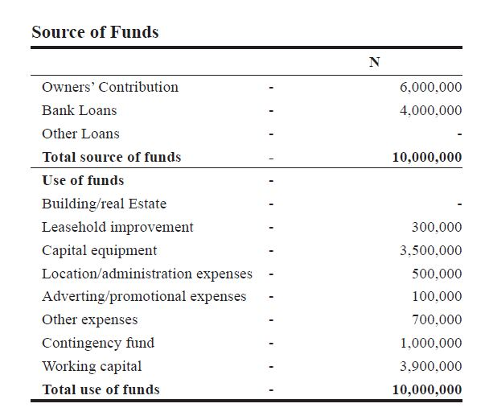

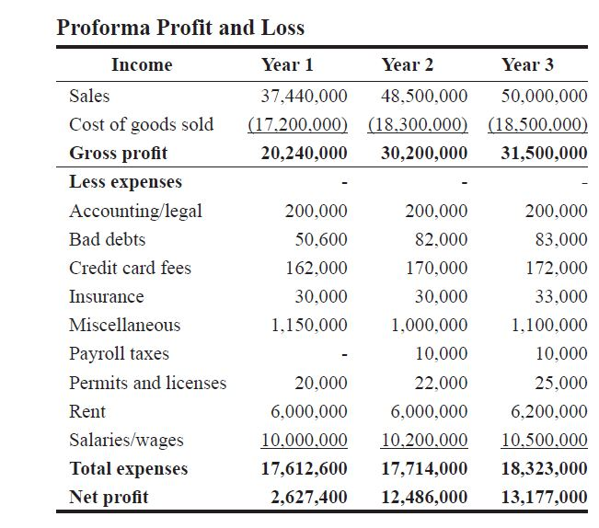
Weekly Sales Projections
Restaurant Business Plan Weekly Sales Projection
Estimated Square feet - 2,000
Average Breakfast price - 300
Average Launch Price - 400
Average Dinner Price - 400
Number of Seats – 56
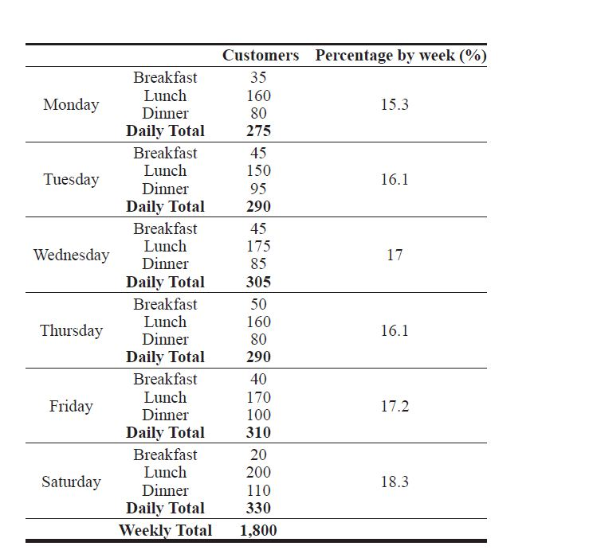

RECAP

Key sales figures
Annual Sales 37,440,000
Average Monthly Sales 3,120,000
Annual Sales per seat 668,571

CONCLUSION
Entering into this market will not be easy, the industry is highly competitive with periodic over capacity, low margins and low entry/exist barriers.
In addition, there are large numbers of substitutes and the suppliers to this market have a great deal of power.
In order to overcome these issues, the restaurant has to acquire an excellent locality in the down town area and intends to provide a suitably upscale environment to draw in the restaurant main target market segment and business professionals.

The company will seek to provide these customers with the maximum number of services to create the greatest sales volume during the restaurant peak hthes of operation.

The restaurant will have a comprehensive marketing, advertising and promotion campaign that will maximize word of mouth marketing and will consist of radio, printed materials, bill boards and discounts.

The restaurant has planned to offer its products at a slightly higher price than its competitors. This is to provide credibility to its clients as an upscale establishment that provides a unique menu.

This will also provide the funds to cover the higher than expected operating costs due to the differentiated and expanded menu.

The sales projections assume 1,800 customers per week. This resulting to the weekly sales of just over N720,000:00 this if projected for three (3) years is calculated as N720,000 X 52 weeks = N37,440,000:00 for 3 years (N37,440,000x3) = N112,320,000:00 By this, the restaurant is maintaining a healthy cash flow.

KEYS TO SUCCESS

• First Impression
Every customer who comes in once should want to return, and recommend us to others. This implies that word of mouth marketing is powerful.
• Location
The restaurant will be close to the market because the customers need not to travel before reaching us.
• Affordability
The restaurant will have varieties of food for the customer’s satisfaction. The price is high enough to establish credibility but not so high as to discourage customers patronage.

